III. To what extent did women contribute to the war effort?
Use the documents on the next pages to fill in the mind map.
The documents have been mixed up. For each one, find the main piece of information it gives you about the role of women during the war, and write it down in the corresponding box of the mind map.
Encouraging men to join the army:
To what extent did women contribute to the war effort?
Feeding the country :
Replacing men in the industry:

Joining the army:

Source 1: Part of the Oath of the Women’s Active Service League:
“At this hour of England’s grave peril and desperate need, I do hereby pledge myself most solemnly in the name of the King and Country to persuade every man that I know to offer his services to the country, and I also pledge myself never to be seen in public with any man, who being in every way fit and free for service, has refused to respond to his country’s call.”

Source 2: Members of the Women's Land Army feeding pigs and calves during WWI (source: Imperial war museum website)
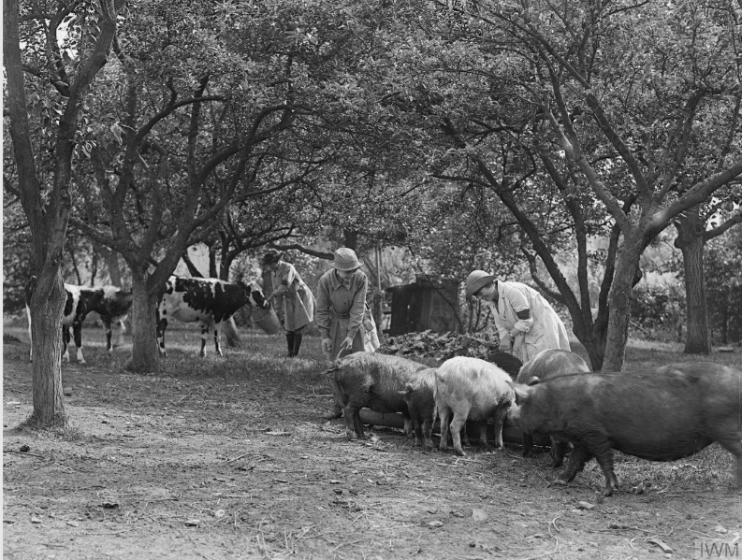

Source 3: archive film, A Day In The Life Of A Munitions Worker, made in 1917 at the Chilwell Arms Factory in Nottinghamshire. (watch the 8 small videos, there is no sound!) :

https://www.iwm.org.uk/history/a-day-in-the-life-of-a-munitions-worker
Source 4: Poster encouraging women to join Queen Mary’s Army Auxiliary Corps (QMAAC), formed in 1917. The QMAAC recruited over 57,000 women during the war for tasks in support of the Army, ranging from catering to office work. Many served in France close to the front line. (Source : imperial War Museum website)
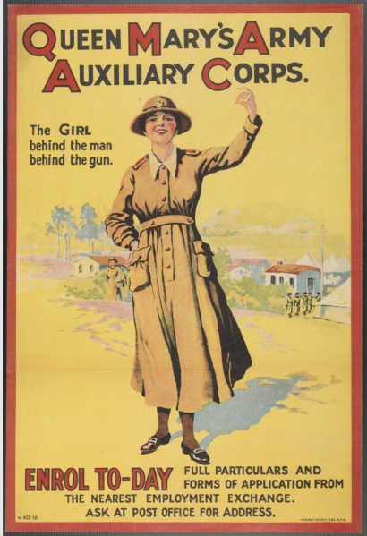
Source 5: Image from “The White Feather: A Sketch of English Recruiting” by Arnold Bennett, in the Collier’s Weekly, 1914.
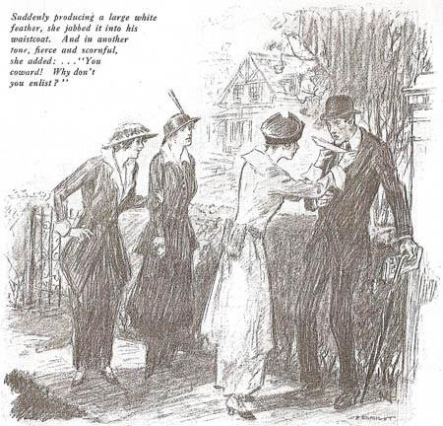

Source 6: Members of the Women's Army Auxiliary Corps (WAAC) drilling in Hyde Park. (Source : Imperial War Museum website)
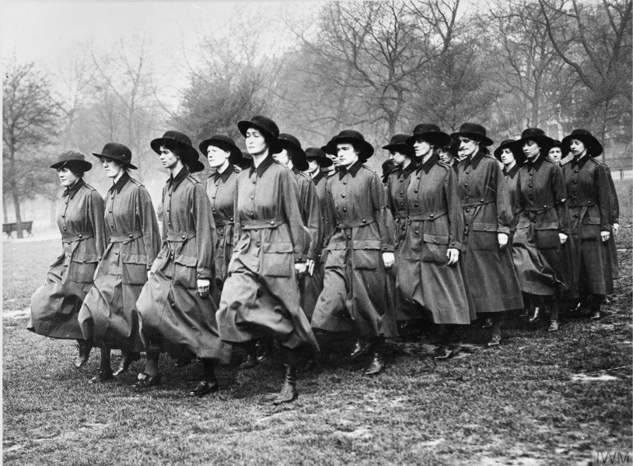

Source 7: Recruitment poster for the Women’s Land Army, 1917. (source: Imperial War museum website)
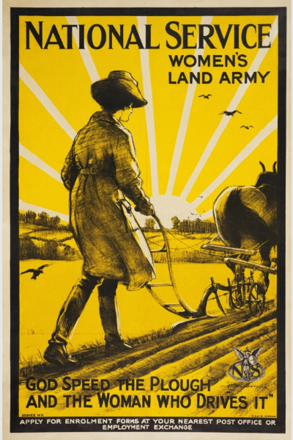

Source 8: Female workers in a rubber factory in Lancashire, September 1918. Making these products (here, tyres) required technical skill. September 1918 (Source: Imperial War Museum website).
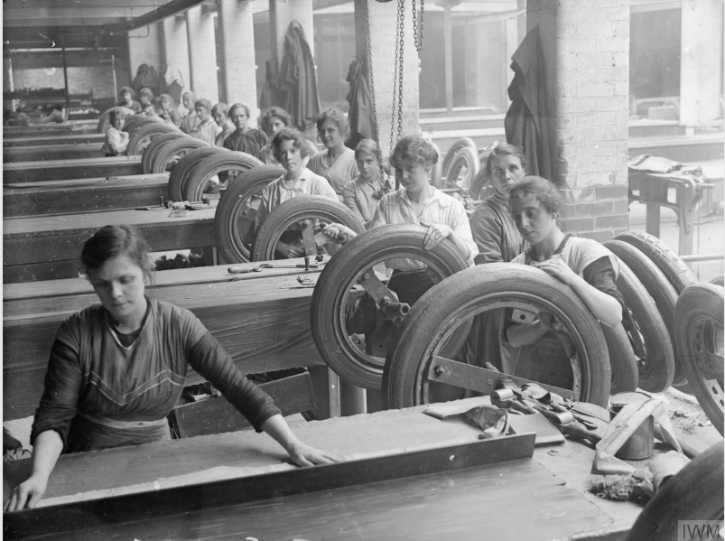

FINISHED ?
Create a 2-3mn audio recording to answer the question: “To what extent did women contribute to the war effort?” and send it to me by WhatsApp.
Use the documents to illustrate your presentation.

The white feather symbolized cowardice and male weakness. Women would refuse to marry men with white feathers.
Drilling = (here) training

