III. To what extent did women contribute to the war effort?
Encouraging men to go to the front:
Women’s associations such as the the Women’s Active Service League were created to encourage men to enlist (source 1), occasionally resorting to violence. The women in these associations would refuse to marry or even just go out with fit men who didn’t enlist in the army (source 1).

They would also organize actions such as distributing white feathers to shame the men they considered as cowards (Source 5)

Feeding the country :
The government created the Women’s Land Army in 1917 to incite women to participate in farming work and food production. In the organisation, women participated in all kinds of farming work, from ploughing (source 7) to raising cattle (source 2).
It was an organisation of volunteers so the government had to create recruitment campaigns to incite women to join (source 7).
Replacing men in the industry:
With many men gone to the front, the industry was in desperate need of skilled workers. Quickly, the government incited women to participate in the war effort by taking their places in factories. Women became as skilled as men in many cases (source 8).
They worked long hours (source 3, video 1), sometimes in difficult and dangerous conditions and without enough protection (source 3).
Joining the army:
As soon as the war broke out, some women wanted to join the army, and actively participate in the war but it wasn’t possible.
In 1917, the government created the Women's Army Auxiliary Corps (WAAC) (source 6), later called the Queen Mary’s Army Auxiliary Corps (QMAAC) (source 4).
In this military corps, 57,000 women worked to support the army, either on the home front, or close to the front (but never on the front line) (source 4).
To what extent did women contribute to the war effort?

Source 1: Part of the Oath of the Women’s Active Service League:
“At this hour of England’s grave peril and desperate need, I do hereby pledge myself most solemnly in the name of the King and Country to persuade every man that I know to offer his services to the country, and I also pledge myself never to be seen in public with any man, who being in every way fit and free for service, has refused to respond to his country’s call.”

Source 2: Members of the Women's Land Army feeding pigs and calves during WWI (source: Imperial war museum website)
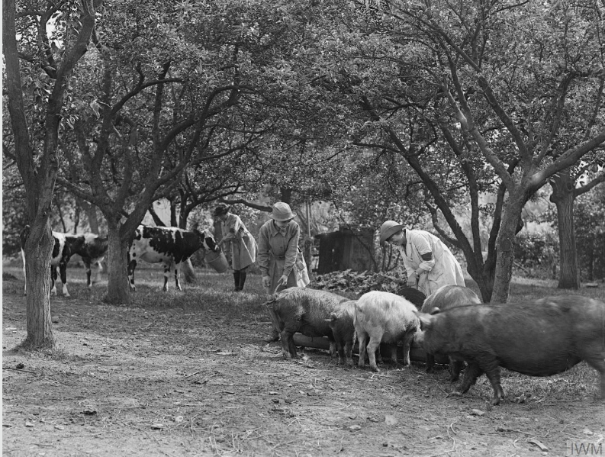

Source 3: archive film, A Day In The Life Of A Munitions Worker, made in 1917 at the Chilwell Arms Factory in Nottinghamshire. (watch the 8 small videos, there is no sound!) :

https://www.iwm.org.uk/history/a-day-in-the-life-of-a-munitions-worker
Source 4: Poster encouraging women to join the Queen Mary’s Army Auxiliary Corps (QMAAC), formed in 1917. The QMAAC recruited over 57,000 women during the war for tasks in support of the Army, ranging from catering to office work. Many served in France close to the front line. (Source : imperial War Museum website)
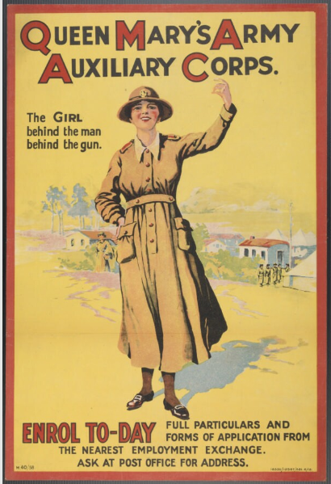
Source 5: Image from “The White Feather: A Sketch of English Recruiting” by Arnold Bennett, in the Collier’s Weekly, 1914.
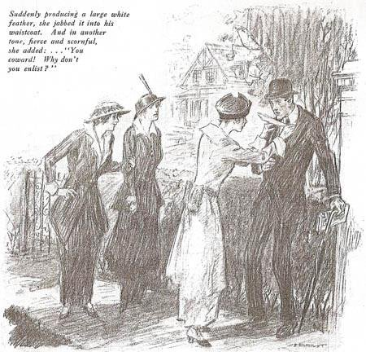

Source 6: Members of the Women's Army Auxiliary Corps (WAAC) drilling in Hyde Park. (Source : Imperial War Museum website)
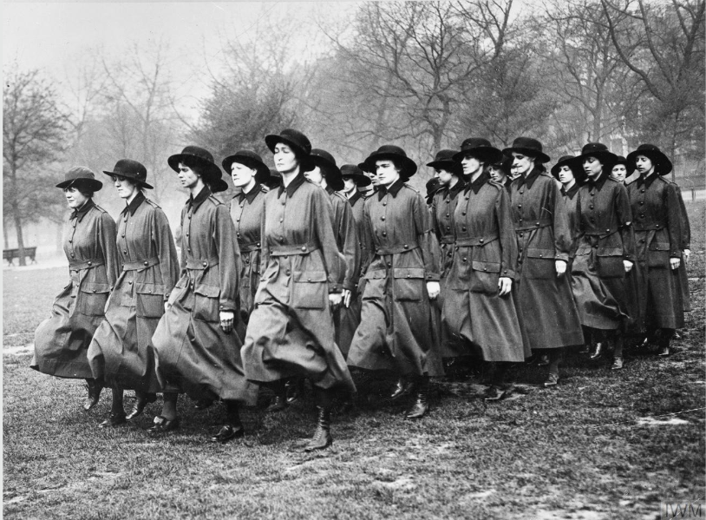

Source 7: Recruitment poster for the Women’s Land Army, 1917. (source: Imperial War museum website)
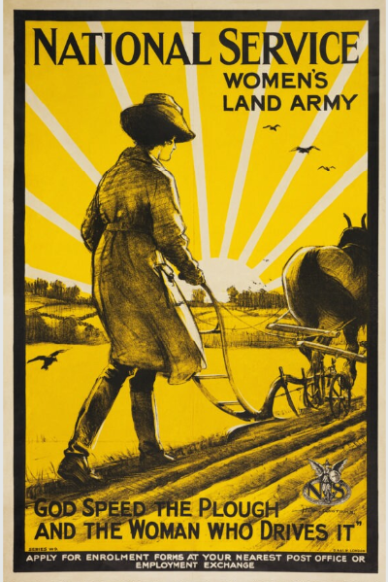

Source 8: Female workers in a rubber factory in Lancashire, September 1918. Making these products (here, tyres) required technical skill. September 1918 (Source: Imperial War Museum website).
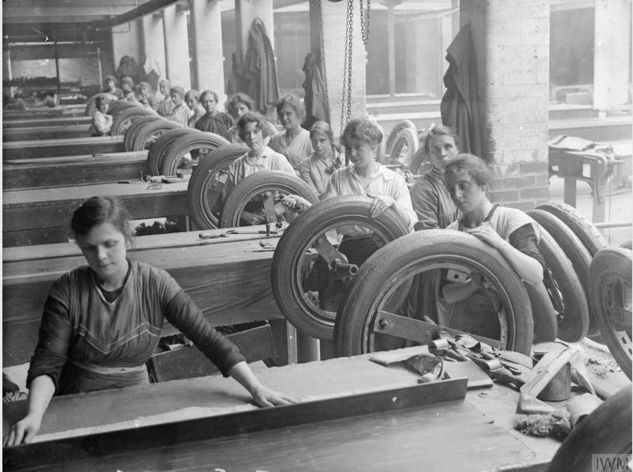

FINISHED?
Create a 2-3mn audio recording to answer the question: “To what extent did women contribute to the war effort?” and send it to me by WhatsApp.
Use the documents to illustrate your demonstration.
Barème:
Intro: /0.5
Encouraging men to enlist /1
Feeding the country /1
Replacing men in factories /1
Joining the army /1
Conclusion / 0.5
Qualité de l’anglais : /5
TOTAL:

The white feather symbolized cowardice and male weakness. Women would refuse to marry men with white feathers.
Drilling = (here) training

