1. **1973-1990…: a love-hate relationship**
   1. **1973-1979: the UK enters Europe… for good?**

In 1974, the elections brought the Labour party (= left wing) back into power. They criticized the conditions the UK had to agree on to enter the EEC and asked for a renegotiation. The European partners agreed on some of the conditions and in 1975, a referendum was organized about whether the UK should remain in the EEC or not.

Source 3:

1. **What’s the historical context of this source, in the World? In Europe?**

In the world: decolonization the UK doesn’t benefit from the support of its empire anymore; In Europe: The UK entered the EEC in 1973; In the UK: electoral campaign for the referendum about EEC membership.

1. **Describe and analyze the source. What’s the message delivered by the cartoonist?**

In the foreground: an overcrowded life boat is landing on Europe’s coast. The passengers come from a luxurious ship called “Commonwealth” that is sinking in the background. The captain (Prime minister Wilson) asks the passengers to wait before stepping ashore and choose whether to land in Europe or return to the Commonwealth.

The cartoonist wants to suggest that in 1975, the UK doesn’t really have a choice but to stay in the EEC on the occasion of the referendum as the Commonwealth doesn’t offer as much support as the former Empire did.

Source 3 : Gibbard, *The Guardian*. 27.02.1975. (the word written on the ship is “Commonwealth”)

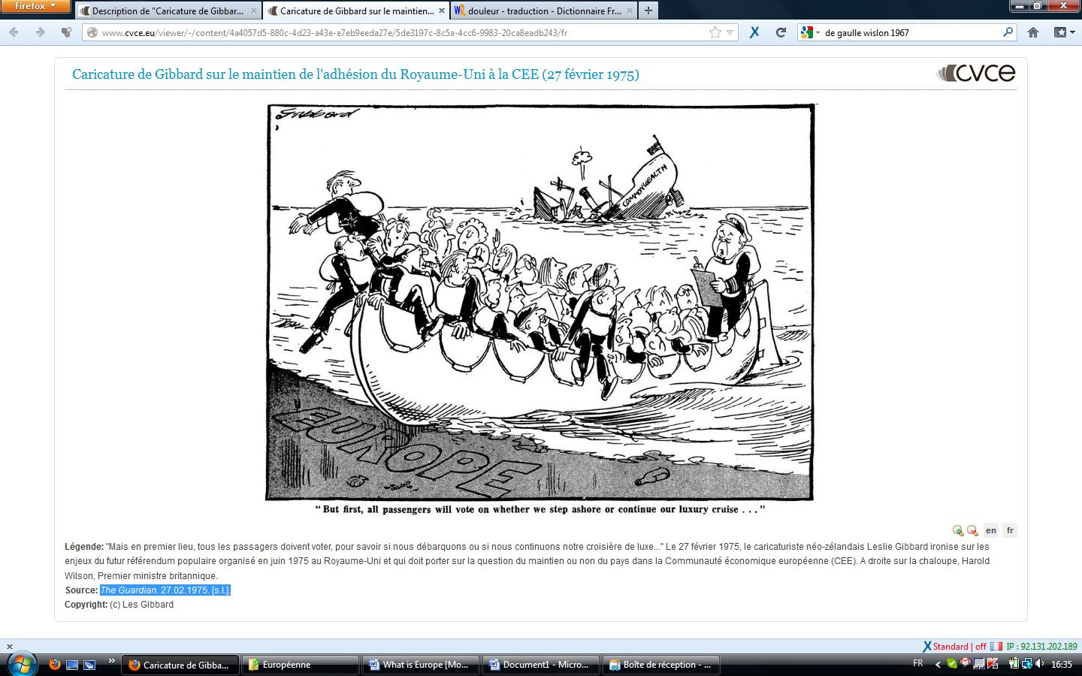

**The answer was YES with 67.2%. So the UK remained in the EEC.**

* 1. **1979-1990: The Thatcher era**

## Thatcher’s vision of Europe

## Source 4: <https://www.youtube.com/watch?v=sh3h3fvlekY>

## Who was Margaret Thatcher (position, political party, details about her…)?

## Leader of the Conservative Party, she became the first female Prime Minister in 1979, and first female head of state in Europe. She was nicknamed “The Iron Lady” due to her strict positions during negotiations.

## What was her opinion about Europe at the beginning of her career? At the beginning, she was in favor of the European project, especially the Common Market. She thought that it would be good for the UK economically speaking. She campaigned FOR membership during the 1975 referendum.

## What did she ask for in 1984? What were her arguments? She asked for a rebate (*ristourne*) on the UK’s contribution to the EEC budget. She said that the UK was giving too much money to Europe, and not receiving enough support in exchange (especially through the Common Agricultural Policy).

## Did she obtain anything from the European community? Yes, she obtained a 66% rebate

## What did she say in her “Bruges speech” of 1988? She made it clear that she was against a federal Europe dominated by Brussels and that she wanted to keep the UK’s sovereignty.

## In 1979, the Conservatives (= Tories) won the general election. The leader of the Party, Margaret Thatcher became Prime Minister. She was not a “Europhile” at all because she disliked the unfair treatment the UK received from the EEC.

## She thought that the UK’s contribution to the European community was too high compared to the money it earned back for the CAP for example (Common Agricultural Policy): “I want my money back”. At the time, the UK was one of the poorest countries of the EEC. So, she threatened to halt payments to the EEC budget.

## She won the “UK rebate” in 1984: the contribution of the UK to the EEC budget was reduced by 2/3!

Using the source, explain what vision Margaret Thatcher had of Europe.

She was for a Europe of sovereign nations and against federal Europe.

2. What did she refer to when she said: “Some of the founding fathers of the Community thought that the United States of America might be its model.

But the whole history of America is quite different from Europe.”?

Source 5: Margaret Thatcher, 1988 Sep 20 Tu, **Speech to the College of Europe, Bruges.**

**Willing Cooperation Between Sovereign States**

My first guiding principle is this: willing and active cooperation between independent sovereign states is the best way to build a successful European Community.

To try to suppress nationhood and concentrate power at the centre of a European conglomerate would be highly damaging and would jeopardise the objectives we seek to achieve.

Europe will be stronger precisely because it has France as France, Spain as Spain, Britain as Britain, each with its own customs, traditions and identity. It would be folly to try to fit them into some sort of identikit European personality.

Some of the founding fathers of the Community thought that the United States of America might be its model.

But the whole history of America is quite different from Europe.

[…]

But working more closely together does not require power to be centralised in Brussels or decisions to be taken by an appointed bureaucracy.

Indeed, it is ironic that just when those countries such as the Soviet Union, which have tried to run everything from the centre, are learning that success depends on dispersing power and decisions away from the centre, there are some in the Community who seem to want to move in the opposite direction.

Certainly we want to see Europe more united and with a greater sense of common purpose.

But it must be in a way which preserves the different traditions, parliamentary powers and sense of national pride in one's own country; for these have been the source of Europe's vitality through the centuries.

## In 1988, in her Bruges speech, she reaffirmed her opposition to a federal Europe and to the idea that the European Community could have its own resources.

## She also refused the common currency (the ECU = European Currency Unit) in 1990.

## The role of the media in the relationship between the UK and Europe

Attention: le document suivant contient de la vulgarité !!! ;-)

Source 6: Front cover of the Sun, November 1st, 1990.

“Up yours” = va te faire… ; This gesture is the equivalent of the French middle finger up.; To stuff = farcir, fourrer…

## Questions:

## Present the source.

## This source is a front cover of The Sun, a British tabloid. It was published on November 1st, 1990, when Jacques Delors, President of the European Commission proposed the project of a common currency for European countries (= the ECU)

## What’s the message “The Sun” wants to convey to Jacques Delors?

## “The Sun” wants to say that the British people will never accept a common currency (“*where he can stuff his ECU*”). They want to keep their monetary sovereignty.

## It is a good illustration of the violence the British media used towards the European construction during Margaret Thatcher’s terms.

## In 1990, Margaret Thatcher’s relationships with Jacques Delors (president of the European Commission) were appalling. This conflict was closely covered by the British media such as the Sun This largely influenced the public opinion about Europe, making Euroscepticism rise in the country:

## *Euroscepticism means criticism of the* [*European Union*](https://en.wikipedia.org/wiki/European_Union) *(EU) and* [*European integration*](https://en.wikipedia.org/wiki/European_integration)*. It can also mean opposition to and total rejection of the EU.*