The British Home Front during WWI

Introduction: WWI was a “Total War”, which means that all aspects of the society were involved, not only soldiers on the front.
How was the British society reorganized to face WWI?

- From recruitment to conscription…
At the beginning of WWI, the British army was small and only professional. So the government started a massive recruitment campaign.
Question: Describe the method each of the 3 posters uses to encourage men to join up. What arguments are used, what feelings do they play on?
How would you have felt if you had been a young man in 1914-1915?

Source 1: the 1914-1915 recruitment campaign
1914 recruitment poster featuring Lord Kitchener, a former successful general who became Secretary of State for War and the figurehead of the recruitment campaign.
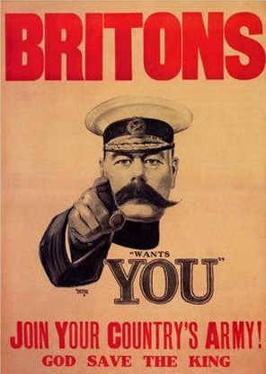On the first poster (featuring Lord Kitchener), the author plays on the patriotism of young men and the fact that they want to defend their country and their king. It also gives the feeling that Lord Kitchener is asking each individual (“Wants you”) to participate.

A 1915 recruitment poster: 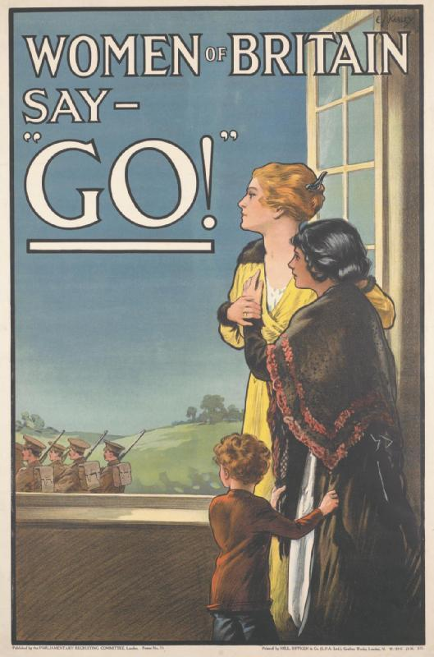The second poster (women) implies that all women of the country agree to make the sacrifice of their son / husband / brother for the country, and encourage them to go to the front..

A 1915 recruitment poster: 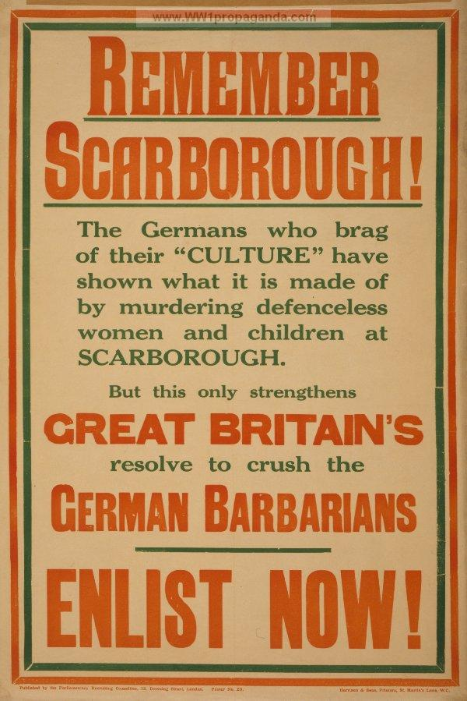The last poster recalls a traumatic event that occurred in Scarborough in 1914: on the morning of 16 December 1914, the North Sea ports of Hartlepool, West Hartlepool, Whitby and Scarborough were bombarded by the German First High Seas Fleet Scouting Group. 137 people lost their lives and 592 people were wounded. This poster uses the incident to try and encourage people to enlist. It plays on the fear of people that it might occur again if they don’t join up.

- Present the document below. This document is the testimony of a Quaker about the reaction of people when they say that they don’t want to go to the front for religious reasons. It was published by the Quakers, on 21 January 1916
- What criticism did the conchies have to face in the society? They’re accused of being cowards or 'shirkers', and of letting other people die for them and for their country. They’re accused of wanting the defeat of their country.

Source 2: The Friend (published by the Quakers, a religious group who believed in non-violence), 21 January 1916
THE HARDEST QUESTION OF ALL
'Then you are willing to see your country defeated?'
That's the question that stops the mouths of many of us when we are trying to explain our position as 'conscientious objectors' ... There is, I believe, hardly one of us who would, or could, say 'Yes'; but, if we say 'No,' we are at once open to the crushing reply, 'Then you are willing to let other men fight and die for you, while you stay quietly and safely at home.'
The 1914-1915 recruitment campaign was highly successful. Half a million people signed up in the 1st month. By 1916, over 2 million had been enlisted.
In 1916, the government decided to introduce conscription for the 1st time: all men aged between 18 and 40 had to register for active service. They could be called up at any time to fight.

At first, people reacted well because:
  - The number of volunteers was falling but the demand for troops was increasing.
  - The volunteer system was damaging Britain’s agriculture and industry.
  - This system was seen as unfair as not all parts of the population took part equally in the effort.
But not all people welcomed conscription well. Some people were opposed to the war for religious or political reasons. They were called “conscientious objectors” or “conchies”. They had to appear before a tribunal to prove they had a genuine reason for objecting to war.

Task: Imagine you’re a young man in 1915. You’re trying to convince your friends to enlist with you in the Army and go to the front. Create a 2mn speech to convince them. Record it and send it to me by WhatsApp.
If you need ideas: visit this site: https://www.iwm.org.uk/learning/resources/first-world-war-recruitment-posters

Proposition de barème /5:
Respect de la forme du discours : /1
Qualité de la langue /2
Arguments : /2
Qualité de la langue: /5

TOTAL : /10

