The British Home Front during WWI

Introduction: WWI was a “Total War”, which means that all aspects of the society were involved, not only soldiers on the front.
How was the British society reorganized to face WWI?

- From recruitment to conscription…
At the beginning of WWI, the British army was small and only professional. So the government started a massive recruitment campaign.

Question: Describe the method each of the 3 posters uses to encourage men to join up. What arguments are used, what feelings do they play on?
How would you have felt if you had been a young man in 1914-1915?
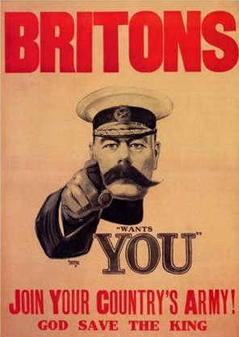
Source 1: the 1914-1915 recruitment campaign
1914 recruitment poster (right) featuring Lord Kitchener, a former successful general who became Secretary of State for War and the figurehead of the recruitment campaign. →

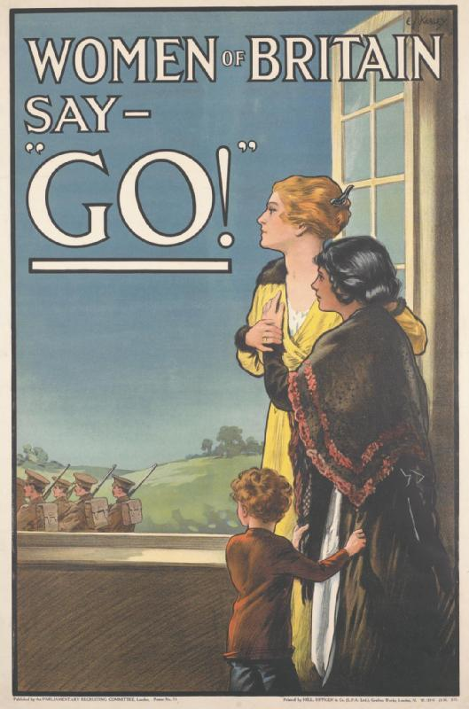
← A 1915 recruitment poster

A 1915 recruitment poster ↓

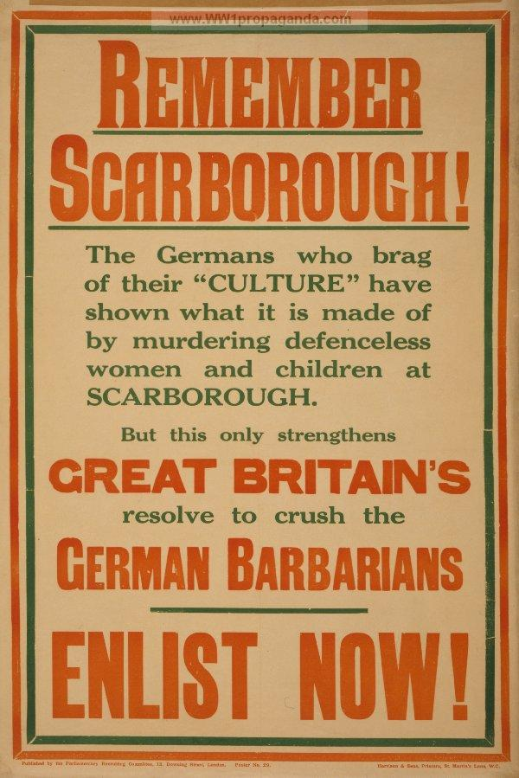

Question:
- Present the document below.
- What criticism did the 'conchies' (= conscientious objectors) have to face in the society?

Source 2: The Friend (published by the Quakers, a religious group who believed in non-violence), 21 January 1916
THE HARDEST QUESTION OF ALL
'Then you are willing to see your country defeated?'
That's the question that stops the mouths of many of us when we are trying to explain our position as 'conscientious objectors' ... There is, I believe, hardly one of us who would, or could, say 'Yes'; but, if we say 'No,' we are at once open to the crushing reply, 'Then you are willing to let other men fight and die for you, while you stay quietly and safely at home.'

The 1914-1915 ___________ campaign was highly successful. Half a million people signed up in the 1st month. By 1916, over 2 million had enlisted.
In 1916, the government decided to introduce ____________ for the 1st time: all men aged between 18 and 40 had to register for active service. They could be called up at any time to fight.

At first, people reacted well because:
  - The number of volunteers was falling but the demand for troops was __________.
  - The volunteer system was damaging Britain’s agriculture and industry.
  - This system was seen as unfair as not all parts of the population took part equally in the effort.
But not all people welcomed conscription. Some people were opposed to the war for ___________ or political reasons. They were called “conscientious objectors” or “conchies”. They had to appear before a tribunal to prove they had a genuine reason for objecting to war.

Task: Imagine you’re a young man in 1915. You’re trying to convince your friends to enlist with you in the Army and go to the front. Create a 2mn speech to convince them. Record it and send it to me by WhatsApp.
If you need ideas: visit this site: https://www.iwm.org.uk/learning/resources/first-world-war-recruitment-posters

Home Front = l’Arrière
Conscription = compulsory enrolment in the army.

