- What are the concerns for the future?
Remember: a posted worker = an employee who is sent by his employer to work in another EU Member State on a temporary basis.

Source 1: “The3million”
“The3million” demonstration in front of Westminster Palace (= Houses of Parliament”), London.
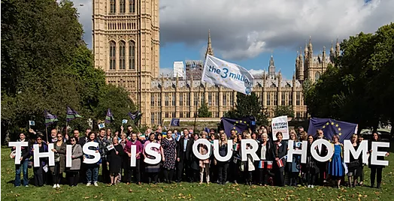
“the3million” is the largest campaign organisation for EU citizens in the UK, formed after the 2016 EU referendum to protect the rights of people who have made the UK their home.
We take our name from the estimated number of EU citizens who moved from another member state and have established a life in the UK. Our objectives are to:
- Defend the right of EU citizens to live, work, study, raise families, and vote in the UK as they do now - whatever the outcome of Brexit.
- Protect EU citizens’ rights through advocacy in UK and EU institutions, influencing public opinion, and mobilising European and British citizens.
- Ensure that EU citizens in the UK know their rights and are empowered to stand up for them.
(Source: “The3million” website, https://www.the3million.org.uk/ )

Questions source 1:
- Comment on the picture: where does the scene take place? Who are the people in the picture? Why did they choose this particular place? What is their message / why are they demonstrating?
- Using the text, explain in your own words what “The3million” is. What is the “danger” they’re fearing (quote the text)?

Source 2: Cartoons published on Forbes website, on October 22, 2018 (CEO = PDG in French): https://www.forbes.com/sites/freylindsay/2018/10/22/labor-migration-in-sweden-laval-social-dumping/#62b21132739a
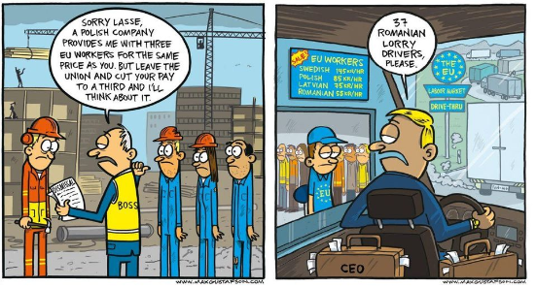
Questions about source 2:
- According to this source, what are the 2 main fields posted workers work in (quote elements from the pictures to justify your answer)?
- According to this source, why do people in Western Europe hire (= employ) Eastern European workers instead of local workers?
- Explain why this situation can create concern for both eastern and western European workers.

Source 3:
“The EU has passed a law requiring firms to comply with local standards when they post workers temporarily to another EU country.
The revised rules adopted by the European Parliament mean posted workers will be entitled to the same level of pay as their local counterparts.
In France, the UK and Germany there have been complaints of unfair competition from cheaper eastern European labour, said to undercut locals.[...]
Under the new rules, firms sending workers to another EU country will have to cover their travel, board and accommodation costs - not deduct those costs from the workers' salaries. […]
The duration of the posting has been set at a maximum of 12 months, with a possible extension of six months. Beyond that period, a worker who stays on will have to be governed by the host country's labour rules.”
“EU tightens law on foreign temporary workers”,
on the BBC website, 29 May, 2018

Questions source 3:
- What is the link between this document and source 2? Quote the text to justify your answer.
- What is the EU’s answer to the concerns about posted workers from Eastern Europe? Quote 2 specific measures from the text.

When you’re finished, create a 2mn audio recording answering the following question: “What are the concerns created by the increased phenomenon of posted workers, how do the EU or other people address these concerns?”
Don’t forget to make a sentence for the introduction and for the conclusion.
You can use the documents to illustrate your presentation.
Send me your recording by WhatsApp.

Advocacy = support
Require = (here) ask
Comply = (here) respect
Counterparts = colleagues
Undercut = to be sold at a cheaper price

