- What are the concerns for the future?
Remember: posted worker = an employee who is sent by his employer to work in another EU Member State on a temporary basis.

Source 1: “The3million”
“The3million” demonstration in front of Westminster Palace (= Houses of Parliament”), London.
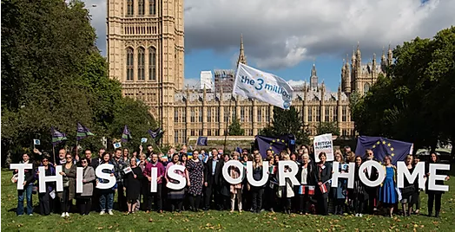
“the3million” is the largest campaign organisation for EU citizens in the UK, formed after the 2016 EU referendum to protect the rights of people who have made the UK their home.
We take our name from the estimated number of EU citizens who moved from another member state and have established a life in the UK. Our objectives are to:
- Defend the right of EU citizens to live, work, study, raise families, and vote in the UK as they do now - whatever the outcome of Brexit.
- Protect EU citizens’ rights through advocacy in UK and EU institutions, influencing public opinion, and mobilising European and British citizens.
- Ensure that EU citizens in the UK know their rights and are empowered to stand up for them.
(Source: “The3million” website, https://www.the3million.org.uk/ )

Questions source 1:
- Comment on the picture: where does the scene take place? Who are the people on the picture? Why did they choose this particular place? What is their message / why are they demonstrating?
These people are Europeans living and working in the UK. The scene takes place in London, in front of Houses of parliament. These people have chosen this place as it is symbolic because it’s the place where the British parliament seats and takes all major decisions, including organizing a referendum for the Brexit. There message is that the Brexit isn’t there choice and they want to continue to live and work in the UK, even if the country lives the EU (“This is our home”).

- Using the text, explain in your own words what “The3million” is. What is the “danger” they’re fearing (quote the text)?
“The3million” is an association of people from other EU countries living and working in the UK. They’re not happy about the Brexit because they’re worried that they’re living and working conditions might change and be degraded after the Brexit. So they’ve decided to create this association to support all people in the same case and make sure that they can keep living in the UK in the same conditions as before the Brexit.

Source 2: Cartoons published on Forbes website, on October 22, 2018 (CEO = PDG in French): https://www.forbes.com/sites/freylindsay/2018/10/22/labor-migration-in-sweden-laval-social-dumping/#62b21132739a
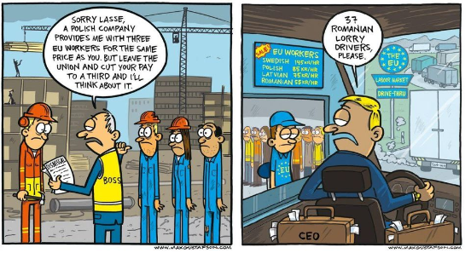
Questions source 2:
- According to this source, what are the 2 main fields the posted workers work in (quote elements from the pictures to justify your answer)?
The posted workers mainly work in the construction and transportation fields (cranes on picture 1 and lorries on picture 2)

- According to this source, why do people in Western Europe hire (= employ) Eastern European workers instead of local workers?
People from Western Europe hire Eastern European workers because they accept lower wages so it costs less for the employers. (example from picture 1: the Swedish worker costs 3 times more than the Polish workers; example from picture 2: the Swedish drivers cost 145 kr/hour, and the Romanian driver costs 55kr/hour, so 2.6 times less.)
Also, most of the time, Eastern European workers aren’t involve in any union and don’t go on strike or protest against any decision, contrary to western European workers who are more used to this democratic right (cf picture 1).

- Explain why this situation can create concern for both eastern and western European workers.
For western European workers, it creates concern because they are afraid of losing their jobs and being replaced by cheaper eastern European workers.
For eastern European workers it creates concern as they see that they’re not paid as much as the western European workers for the same job and it’s not faire.

Source 3:
“The EU has passed a law requiring firms to comply with local standards when they post workers temporarily to another EU country.
The revised rules adopted by the European Parliament mean posted workers will be entitled to the same level of pay as their local counterparts.
In France, the UK and Germany there have been complaints of unfair competition from cheaper eastern European labour, said to undercut locals.[...]
Under the new rules, firms sending workers to another EU country will have to cover their travel, board and accommodation costs - not deduct those costs from the workers' salaries. […]
The duration of the posting has been set at a maximum of 12 months, with a possible extension of six months. Beyond that period, a worker who stays on will have to be governed by the host country's labour rules.”
“EU tightens law on foreign temporary workers”,
on the BBC website, 29 May, 2018

Questions source 3:
- What is the link between this document and source 2? Quote the text to justify your answer.
The link is the fact that Eastern European workers in Western Europe create unfair competition with local workers because they cost less but don’t benefit from the same advantages, and the EU tries to regulate this.

- What is the EU’s answer to the concerns about posted workers from Eastern Europe? Quote 2 specific measures from the text.
The EU has passed a law to force employers to pay local and posted workers at the same price,

When you’re finished, create a 2mn audio recording answering the question: “What are the concerns created by the increased phenomenon of posted workers, how do the EU or other people address these concerns?”
Don’t forget to make a sentence for the introduction and for the conclusion.
You can use the documents to illustrate your presentation.
Send me your recording by WhatsApp.

Barème:

Introdution: /0.5
The “Brexit Issue” and the answer of associations /2
Competition between eastern and western European workers and the EU’s reaction /2
Conclusion /0.5

Qualité de la langue: /5

Total : /10

Advocacy = support
Require = (here) ask
Comply = (here) respect
Counterpart = colleagues
Undercut = to be sold at a cheaper price

