1. **Why work in another European country?**

Working abroad has become more and more common in the EU. Among the people working abroad, 1.4 million are **cross-border workers** (=people who work in one country but live in another) and 2.3 million are **posted workers** (= employees sent by their employers to carry out a mission in another EU Member State on a temporary basis).

1. **Where do foreign workers in Europe come from and go, and why?**

**Source 1: In and out migration, 2017**

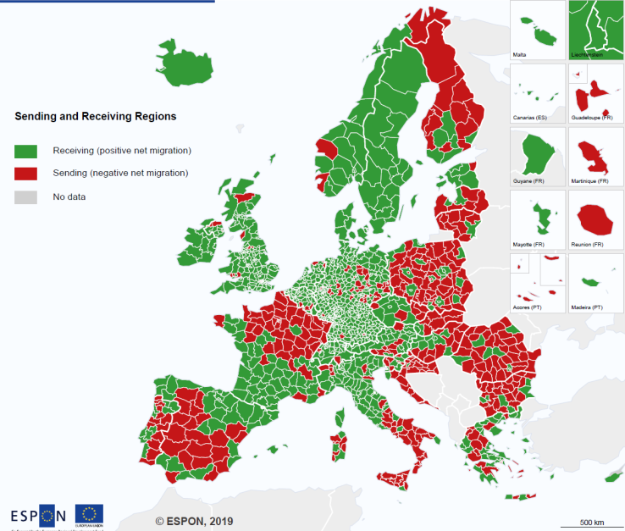 

**Source 2:** […] labor mobility increased greatly after the 2004 and 2007 expansions of the European Union toward the east. In 2004, about two million citizens from Eastern Europe resided in the European Union. During the migration peak in 2007, 1 percent of the citizens of East European countries moved to Western and Southern Europe. By 2009, the total number of nationals from Eastern European countries residing in the EU-15 states increased to 4.8 million. The lifting of labor restrictions in 2014 for Bulgarians and Romanians in nine European Union countries, including Germany, France, and the United Kingdom, prompted another emigration wave. Overall east-to-west migration also picked up after 2014 as economic growth returned to Western Europe. By March 2016, 6.3 million East Europeans resided in other EU states.

c, “Migration in Europe: the story of the East” on *the World Economic Forum website*, Nov. 29, 2016.

<https://www.weforum.org/agenda/2016/11/migration-in-europe-the-story-of-the-east/>

1. **Present sources 1 and 2:** Source 1 is a map of Europe presenting migration rates per region in 2017. It was published by EPSON in 2019. Source 2 is an extract from an article entitled “Migration in Europe: the story of the East”, written by Simeon Djankov on the World Economic Forum website, on November 29, 2016. It deals with migrations flows in Europe.
2. **Which countries do labour migrants come from in majority? (use sources 1 and 2):** According to source 2, the majority of migration flows in Europe come from Eastern countries; for example, according to source 1, countries like Poland, Romania or Bulgaria are considered as “sending countries”.
3. **Which countries do labour migrants go to in majority (use sources 1 and 2):** According to source 2, the majority of migration flows in Europe go to Western countries; for example, according to source 1, countries like the UK, Germany or Belgium are considered as receiving countries”.

**Source 3: year 2018 (*wage = salary*)**

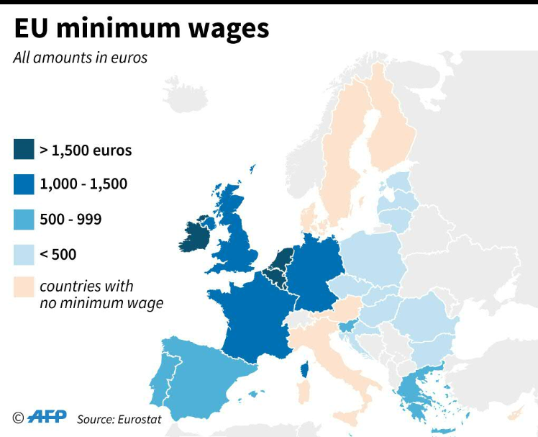

**Source 4:**

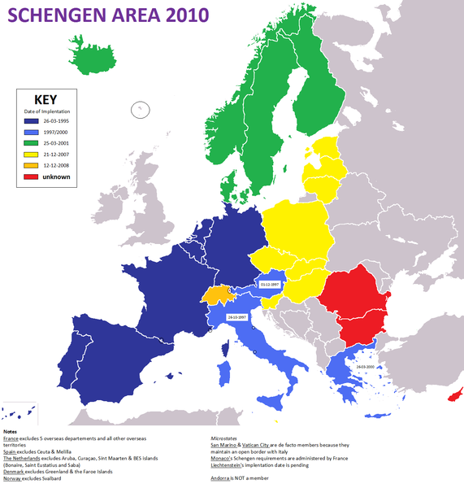

**Source: Wikimedia Commons**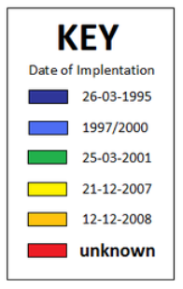

1. **Present sources 3 and 4.**

Source 3 is a map of Europe presenting the amount of the minimum wages (in euros) in the different countries in 2018. It was published by the AFP after Eurostat’s data. Source 4 is a map of Europe showing the Schengen area and the date of entry of each country in this agreement. It comes from the website “Wikimedia Commons”.

1. **How can you explain these labor migration flows in Europe? Give 2 reasons (use sources 2, 3 and 4)**

There are 2 main reasons why the majority of migration flows in Europe come from the east and go to the West:

* According to source 3: minimum wages are higher in western countries such as Ireland, the Benelux, the UK, France and Germany (≥ 1,500€ a month). On the contrary, eastern countries such as Poland, Bulgaria, Romania, the Baltic states… have low minimum wages (≤ 500€ a month). That’s why people from eastern countries are attracted by better wages in Western Europe.
* According to source 2, there was an expansion of the European Union towards the East in 2004 and 2007. Eastern countries such as the Baltic states, Poland, Hungary, Slovakia or the Czech Republic… entered the Schengen area in 2007 (source 4). This made it easier for people to travel across Europe without any passport controls.

**When you’re finished, create a 3mn audio recording to answer the following question: “Where do foreign workers in Europe come from and go, and why?” and send it to me by WhatsApp**

BAREME

Phrase d’intro: /0.5

East to West migration flows + examples of countries /2

Causes of the migration flows (wages + Schengen /2

Phrase de conclusion: /0.5

Qualité de l’anglais : /5

TOTAL :