- Which countries participate the most in the Erasmus program, and why?
Source 1:
- Present the document.
- Where did Erasmus students come from in 2017/2018 (list the 5 most important countries). Generally speaking, are they rather big or small countries?
- On the contrary, which 5 countries sent the smallest numbers of students abroad? Generally speaking, are they big or small countries?

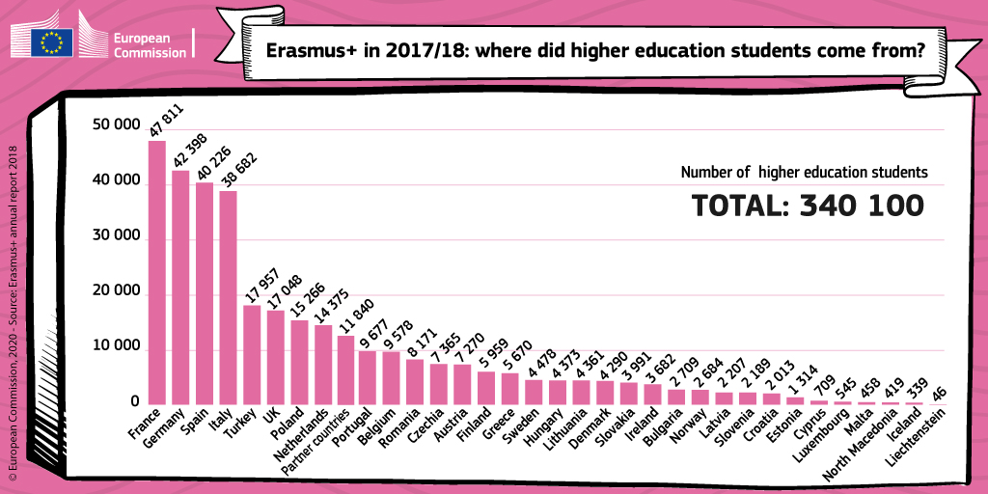

Source 2: right, next column)
- Present the document.
- Where did Erasmus students go in 2017/2018 (list the 5 most important countries). Generally speaking, are they big or small countries?
- On the contrary, which 5 countries received the smallest numbers of foreign students?
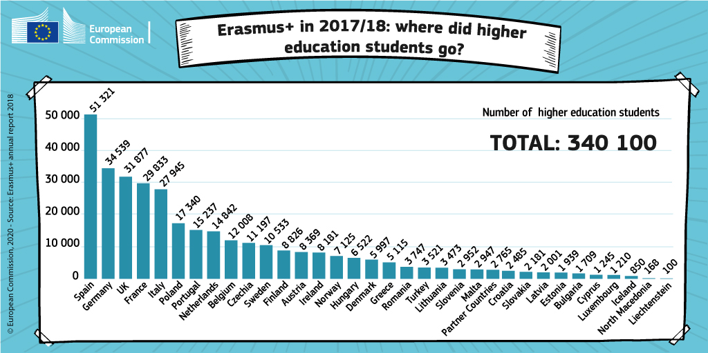

Source 3: Countries participating in the Erasmus programme (source: European Commission website 2017) https://ec.europa.eu/programmes/erasmus-plus/anniversary/spotlight-bringing-europe-together_en
- Present the document.
- Using your answers about sources 1 and 2, and source 3, what’s the common characteristic of the countries which participate the most in the Erasmus Programme?
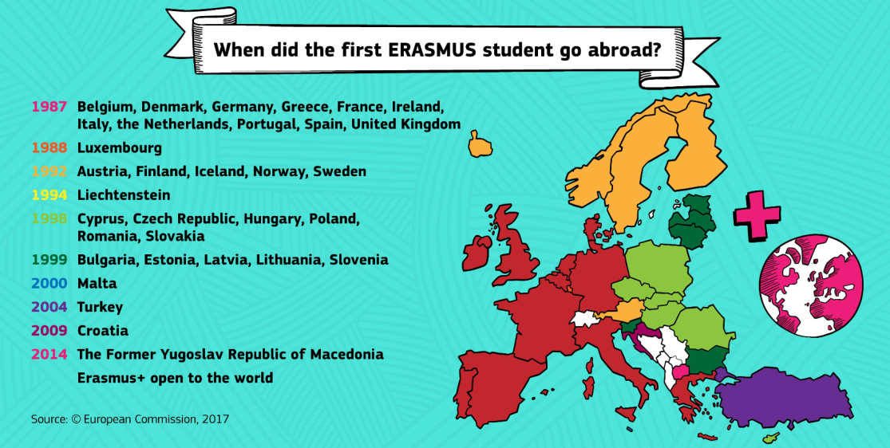

In Europe, the countries that participate the most in the Erasmus programme are the biggest / smallest countries, for example: ______ and _______. That’s because they own a few / a lot of universities participating in the programme. Also, these countries speak a language that is frequently learnt in other countries (English, French, Spanish, German…) Often, they also are the countries which have been members of the EU and the Erasmus programme for the longest / shortest time.

Source 4:
- Can European students only study in Europe? Do European universities welcome only European students? Quote the text to justify you answer.
- Which part of the Erasmus programme budget is dedicated to worldwide projects? How many people are concerned? How many universities?
Source 4:
“What started in 1987 as voluntary cooperation between 11 European countries has developed into a unique global network. Under Erasmus+, it is now possible for students, staff and young people from all over the world to come to Europe, just as Europeans can go to other parts of the world. […]
With about 17% of the Erasmus+ budget going towards projects and scholarships with a worldwide focus, the period stretching from 2014-2020 will see this funding translate into 180,000 students and staff moving between Europe and the rest of the world; 1,000 capacity building projects for higher education; and 30,000 scholarships for students worldwide to take part in Erasmus Mundus Joint Master Degree programmes.
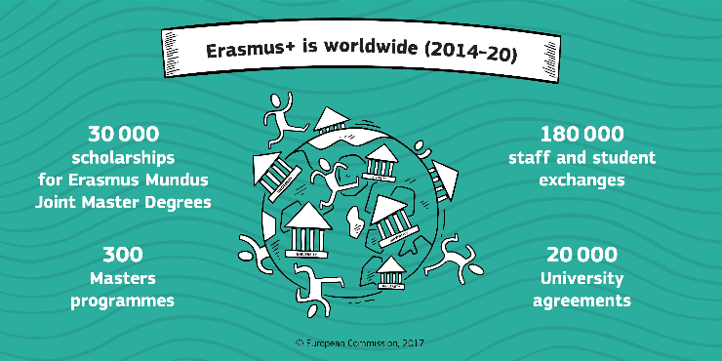
Source : “Erasmus is worldwide”, on the European commission website, 2017 https://ec.europa.eu/programmes/erasmus-plus/anniversary/spotlight-erasmus-worldwide_en

But European students don’t only go to European countries. They can now go to other “partner” countries everywhere in the world. In total, it represents ______ universities. European Universities also welcome students from all over the _____. Overall, about ___ of the budget is dedicated to worldwide projects.

When you’re finished, use your answers to create a 1-2mn audio recording on the topic: “Which countries participate the most in the Erasmus program and why?”.
TRY NOT TO READ YOUR ANSWERS !
Send it to me with WhatsApp.

