- Which countries participate the most in the Erasmus program, and why?
Source 1:
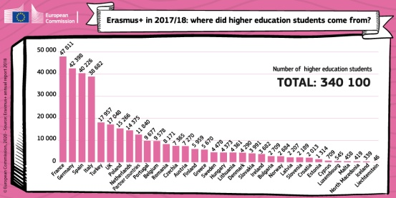
- Present the document:
Graph presenting the countries of origin of Erasmus students in 2017/2018. This graph was published by the European Commission in 2018.

- Where did Erasmus students come from in 2017/2018 (list the 5 most important countries). Generally speaking, are they rather big or small countries?
France, Germany, Spain, Italy Turkey. They’re rather big countries.

- On the contrary, which 5 countries sent the smallest numbers of students abroad? Generally speaking, are they big or small countries?
Luxembourg, Malta, North Macedonia, Iceland and Liechtenstein. They’re small countries.

Source 2:
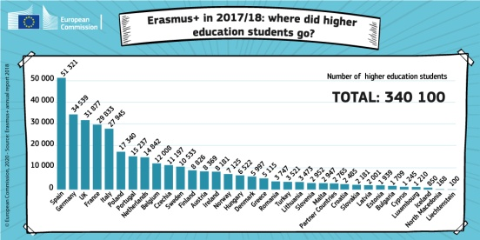
- Present the document:
Graph presenting the destination countries of Erasmus students in 2017/2018. This graph was published by the European Commission in 2018.
- Where did Erasmus students go in 2017/2018 (list the 5 most important countries). Generally speaking, are they rather big or small countries?
France, Germany, the UK and Germany. They’re rather big countries.

- On the contrary, which 5 countries received the smallest numbers of foreign students? Generally speaking, are they rather big or small countries?
Cyprus, Luxembourg, Iceland, North Macedonia and Liechtenstein. They’re small countries or islands.

Source 3: Countries participating in the Erasmus programme (source: European Commission website 2017) https://ec.europa.eu/programmes/erasmus-plus/anniversary/spotlight-bringing-europe-together_en
- Present the document: It’s a map representing the countries participating in the Erasmus Programme with their date of entry in the programme. It was published by the European commission in 2017.

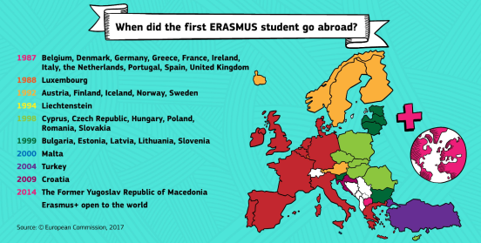
- Using your answers about sources 1 and 2, and source 3, what’s the common characteristic of the countries which participate the most in the Erasmus Programme? Almost all of them (except Turkey) have been part of the Erasmus programme (and the EU) since the beginning in 1987 (France, Germany, Spain, Italy, the UK).

In Europe, the countries that participate the most in the Erasmus programme are the biggest countries, for example: France and Germany That’s because they own a lot of universities participating in the programme. Also, these countries speak a language that is frquently learnt in other countries (English, French, Spanish, German…) Often, they also are the countries which have been members of the EU and the Erasmus programme for the longest time.

Source 4:
- Can European students only study in Europe? Do European universities welcome only European students? No. European students can go all over the world. And students from the whole world can come to Europe.
- Which part of the Erasmus programme budget is dedicated to worldwide projects? How many people are concerned? How many universities? About 17% of the budget is dedicated to worldwide projects, in 20,000 Universities.

Source 4:
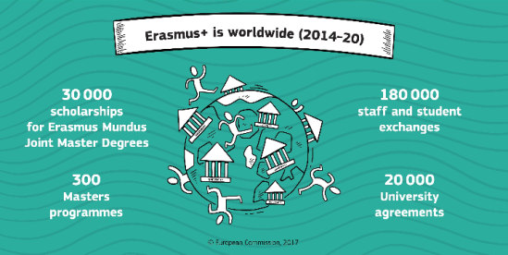
“What started in 1987 as voluntary cooperation between 11 European countries has developed into a unique global network. Under Erasmus+, it is now possible for students, staff and young people from all over the world to come to Europe, just as Europeans can go to other parts of the world. […]
With about 17% of the Erasmus+ budget going towards projects and scholarships with a worldwide focus, the period stretching from 2014-2020 will see this funding translate into 180,000 students and staff moving between Europe and the rest of the world; 1,000 capacity building projects for higher education; and 30,000 scholarships for students worldwide to take part in Erasmus Mundus Joint Master Degree programmes.
Source : “Erasmus is worldwide”, on the European commission website, 2017 https://ec.europa.eu/programmes/erasmus-plus/anniversary/spotlight-erasmus-worldwide_en

But European students don’t only go to European countries. They can now go to other “partner” countries everywhere in the world. In total, it represents 20,000 universities. European Universities also welcome students from all over the world. Overall, about 17% of the budget is dedicated to worldwide projects.

When you’re finished, use your answers to create a 1-2mn audio recording on the topic: “Which countries participate the most in the Erasmus program and why?”. TRY NOT TO READ YOUR ANSWERS !
Send it to me with WhatsApp.

Barème notation oral:
Intro : | /0.5
Countries participating the most and why | /1
Countries participating the least and why | /1
Share of the rest of the world in the programme | /1
Specific examples of countries / figures drawn from the documents | /1
Conclusion : | /0.5
TOTAL | /5
Qualité de l’anglais : /5
TOTAL: /10

