MOBILITIES IN EUROPE :
Moving to study and work inside the European Union

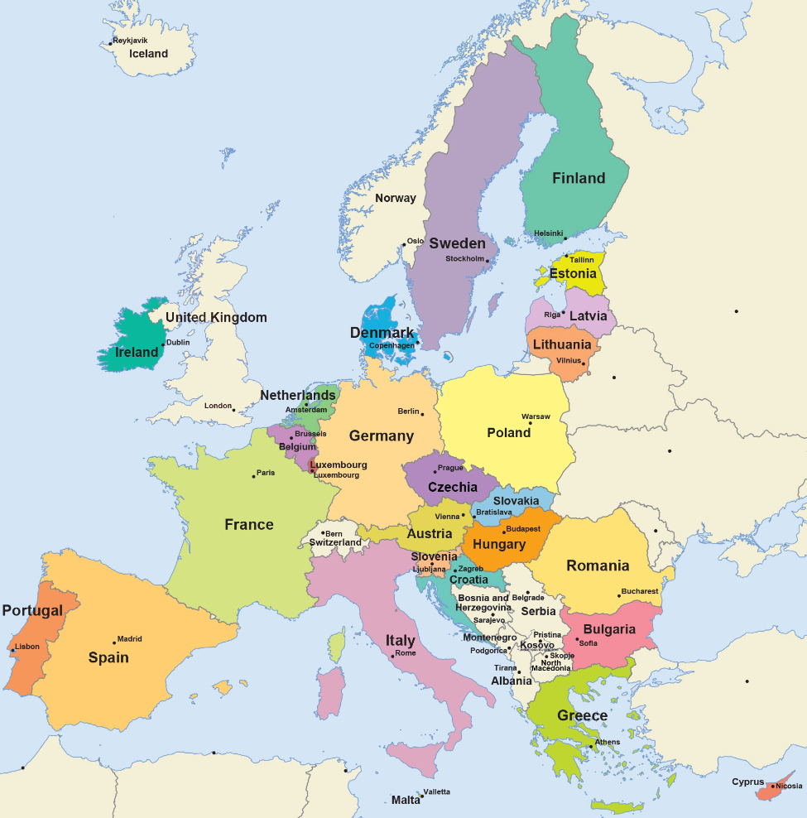
Introduction : Since 1990, the number of Europeans moving inside the EU to work or to study has been increasing. In 2018, 17 million Europeans studied, worked and/or lived abroad (= in another country).
Why do Europeans choose to work and study abroad?

- What are the characteristics of international student flows in Europe?
Studying abroad has become increasingly common among students. In 2017, there were 1.7 million students of all ages in the EU coming from abroad, a number which has increased by 22 % since 2013.

A. Why is it easy to study in another EU country?

Questions relating to all the documents
- Present the sources
- Using the sources, explain why it is easy for European students to study in another country of Europe. Write your answer in one of the boxes of your mind map

Why is it easy to study in another EU country?

Source 1: “The Erasmus Programme (European Region Action Scheme for the Mobility of University Students) was launched in 1987 and since then it has provided European students with the opportunity to experience student life in one of the 33 programme countries. Erasmus student exchanges have a duration of between 3 and 12 months, in which students leave their home university and follow an agreed part of their course at another university in another country. No additional fees are payable, and the course is recognised by the home institution as part of course-work for the degree. Around 90% of European universities are involved in this scheme, which offers students a broad spectrum of courses and study programmes to choose from. Of course, the popularity of the Erasmus Programme has increased over time.”
Source: “Celebrating 30 years of the Erasmus Programme”, European Council website 2017, https://www.consilium.europa.eu/fr/documents-publications/library/library-blog/posts/celebrating-30-years-of-the-erasmus-programme/

Source 2: Countries participating in the Erasmus programme (source: European Commission website 2017) https://ec.europa.eu/programmes/erasmus-plus/anniversary/spotlight-bringing-europe-together_en
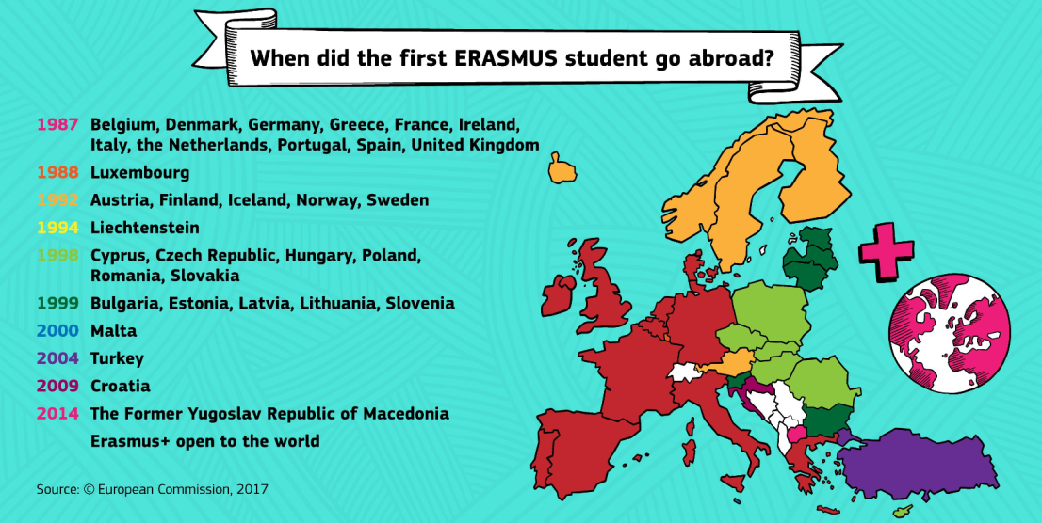
Source 3: The European Higher Education Area
The European Higher Education Area (EHEA) is a unique international collaboration on higher education and the result of the political will of 48 countries with different political, cultural and academic traditions, which, step by step during the last twenty years, built an area implementing a common set of commitments: structural reforms and shared tools. [...] For all these countries, the main goal is to increase staff and students' mobility and to facilitate employability.

Source : EHEA website, 2020 (http://www.ehea.info/)

Source 4: The EHEA members (source: EHEA website, 2020, http://ehea.info/page-full_members)

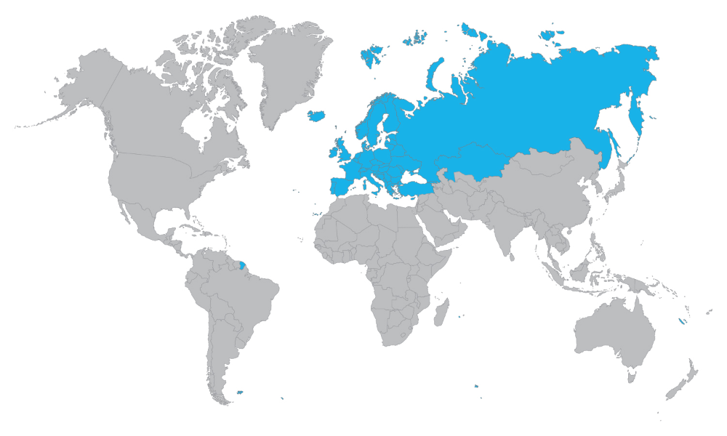
Source 5: Screenshot of the European Commission website 2020 (https://ec.europa.eu/education/resources-and-tools/european-credit-transfer-and-accumulation-system-ects_en ) 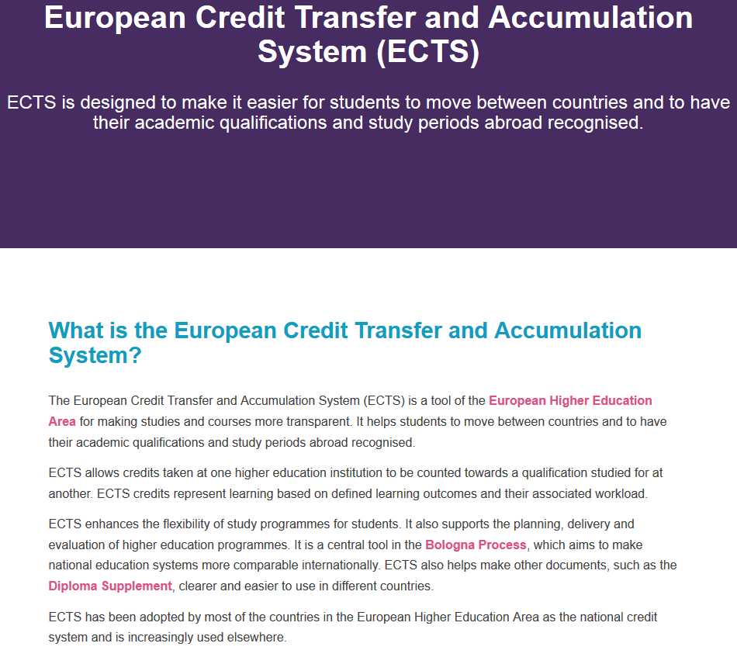

Source 6: The Schengen area
The Schengen Area is an area that includes 26 European countries. All of those countries have signed the Schengen Agreement in Schengen, Luxembourg in 1985.
The Schengen area removes passport control between its member countries. This means travelers who go from one Schengen country to another do not clear immigration checks anymore. Passengers go through immigration checks if they enter or exit the Schengen Area.
Source: “Schengen Area facts for kids” article, on Kiddle Website, 2019, https://kids.kiddle.co/Schengen_Area

Source 7: The Schengen area (Source: European Commission website 2020, https://ec.europa.eu/home-affairs/what-we-do/policies/borders-and-visas/visa-policy/schengen_visa_en)
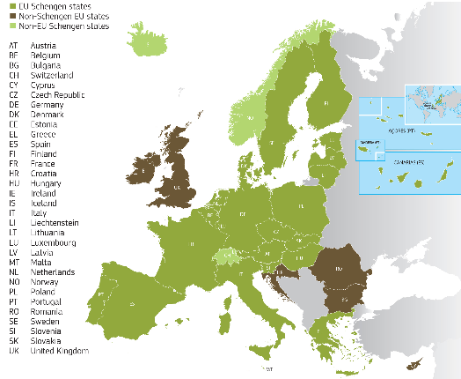

Fees = frais d'inscription
Degree = (here) diploma
Higher education = enseignement supérieur
To implement = mettre en œuvre.
Commitment = engagement
Checks = controls

