II. How did DORA help GB during WWI?
In 1914, the government passed the Defense Of the Realm Act (DORA). It gave the government huge powers to control many aspects of people’s daily lives, the industry, propaganda…

- The munitions crisis
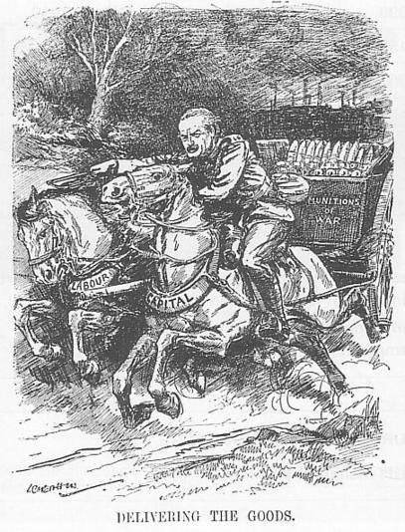
In 1915, there was a chronic shortage of shells, bullets and armaments. It became a national scandal exposed by the “Daily Mail”. Lloyd George, the minister of Munitions, introduced various measures to “Deliver the Goods”:

← Source 3: A 1915 cartoon (the character is Lloyd George)

Questions:
  - According to this cartoon, what did “delivering the Goods” mean for Lloyd George?
  - What means did he use to reach this goal (use the picture to answer)?

  - He forced skilled _______ to stay where the government needed them instead of going to where they got better pay thanks to the government.
  - He brought women into the workforce.

Source 3: Munitions production 1915-1917:
 | Machine guns | Bullets (million) | Shells (million)
1915 | 1700 | 369 | 2
1917 | 19000 | 619 | 23
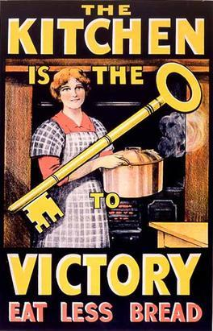
Question: According to this table, were Lloyd George’s measures efficient?

By the end of 1915, the situation had ________. The British army was well supplied with munitions for the rest of the war.

- Feeding the country
Source 4: A government poster issued in 1917 →
Questions:
  - Describe the poster: what are the main elements?
  - What message did the government want to spread? Who is it aimed at?
  - Why was the 'kitchen' the key to victory?

← Source 5: WWI British ration book for butter and margarine coupons.
Questions:
- Present the document
- What does it mean about the measures taken by the government in 1917 to fight against food shortages?

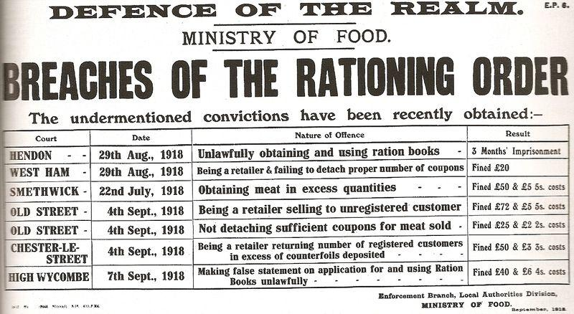
Source 6 (below): A leaflet produced by the government in 1918 →
Questions:
- Present the document
- What does it tell you about the compulsory rationing? (breaches = infractions)

Under DORA, the government was able to take land and turn it over into farm production. In February 1917, it set up the Women’s Land Army to recruit _____ as farm workers.
By then, however, the food supply had become very difficult: in April 1917, German U-boats were sinking ¼ of the British merchant ships. Prices rose and poor people couldn’t afford even basic supplies.
The government responded with various measures:
  - It raised the wages of industrial workers
  - It set up the system of voluntary _________
  - It controlled the price of bread
However, none of these measures was effective in reducing the food shortage, so in early 1918, the government introduced compulsory _________ of sugar, butter, meat, and beer.

Task: When you’re finished, create a 2mn audio recording on the topic: “How did DORA help GB during WWI?”.
Don’t forget to make a sentence for the introduction and the conclusion, and try to organize your answer in 2 or 3 parts… You may use the documents to illustrate your demonstration.
When you’re finished, send me your recording by WhatsApp.

Realm = kingdom
An Act = a law
Shortage = a lack of…

