- How did DORA help GB during WWI?
In 1914, the government passed the Defense Of the Realm Act (DORA). It gave the government huge powers to control many aspects of people’s daily lives, the industry, propaganda…

- The munitions crisis
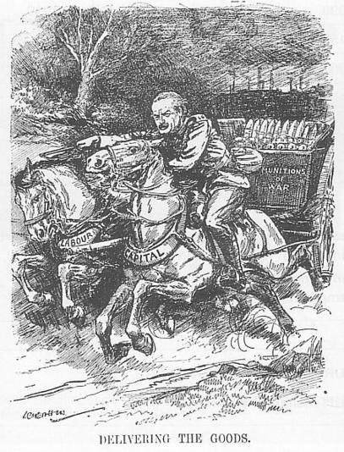
In 1915, there was a chronic shortage of shells, bullets and armaments. It became a national scandal exposed by the “Daily Mail”. Lloyd George, the minister of Munitions, introduced various measures to “Deliver the Goods”:

← Source 3: A 1915 cartoon (the character is Lloyd George)

  - According to this cartoon, what did “delivering the Goods” mean for Lloyd George? “Delivering the goods” meant producing enough munitions for the soldiers on the front (cf. the shells in the cart and the cart’s name: “Munitions of war”).
  - What means did he use to reach this goal (use the picture to answer)? The means he used are written on the horses'necks (=”Labour” and “Capital”) and depicted in the background (cf. the factories). “Labour” = workers of the factories, and “Capital” = government’s money to pay for the workers and the equipment.

  - He forced skilled workers to stay where the government needed them instead of going to where they got better pay thanks to the government.
  - He brought women into the workforce.

Source 3: Munitions production 1915-1917:
 | Machine guns | Bullets (million) | Shells (million)
1915 | 1700 | 369 | 2
1917 | 19000 | 619 | 23
Question: According to this table, were Lloyd George’s measures efficient?
Yes, the production of machine guns was multiplied by 12; the production of bullets almost doubled, and the production of shells was multiplied by 12 too.

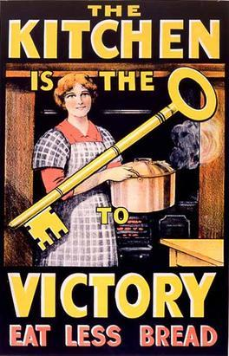
By the end of 1915, the situation had improved. The British army was well supplied with munitions for the rest of the war.

- Feeding the country
Source 4: A government poster issued in 1917 →
  - Describe the poster: what are the main elements? The main elements of this poster are the title with the big key in the middle in the foreground of the picture, and the woman holding a pot in the background. The slogan is: “The kitchen is the key to victory: eat less bread”.
  - What message did the government want to spread? Who is it aimed at? This poster is aimed at women. The government wants them to self-ration themselves and their children at home in order to save bread (and more generally food) for the soldiers on the front.
  - Why was the 'kitchen' the key to victory? Because feeding the country is one of the most important issues the government had to face during the war.
← Source 5: WWI British ration book for butter and margarine coupons.
Questions:
- Present the document: This document is a ration book used during the war. People would use this book to get their daily ration of butter and margarine by giving the coupons every day.
- What does it mean about the measures taken by the government in 1917 to fight against food shortages? Rationing was put in place as the previous measures taken by the government were not sufficient and food shortages still existed.

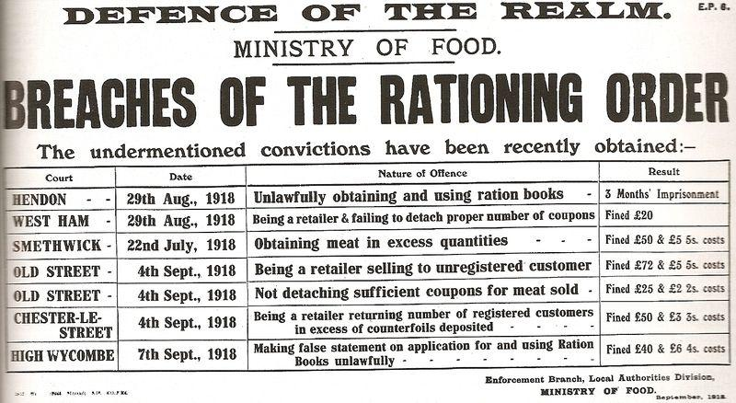
Source 6 (right): A leaflet produced by the government in 1918 →
- Present the document: This document is a leaflet produced by the British government in 1918. It lists the sanctions for not respecting the compulsory rationing in different cities (for example: 3 months of imprisonment for stealing and illegally using ration books in Hendon, or a fine of £50 for trying to get more meat than allowed in Smethwick)
- What does it tell you about the compulsory rationing? (breaches = infractions): The fact that the authorities needed to sanction people who didn’t respect compulsory rationing suggests that people tried to cheat because they didn’t get enough food for them and their families.

Under DORA, the government was able to take land and turn it over into farm production. In February 1917, it set up the Women’s Land Army to recruit women as farm workers.
By then, however, the food supply had become very difficult: in April 1917, German U-boats were sinking ¼ of the British merchant ships. Prices rose and poor people couldn’t afford even the basic supplies.
The government responded with various measures:
  - It raised the wages of the industrial workers
  - It set up the system of the voluntary rationing
  - It controlled the price of bread
However, none of these measures was effective in reducing the food shortage, so in early 1918, the government introduced compulsory rationing of sugar, butter, meat, and beer.

Task: When you’re finished, create a 2mn audio recording on the topic: “How did DORA help GB during WWI?”.
Don’t forget to make a sentence for the introduction and the conclusion, and try to organize your answer in 2 or 3 parts… You may use the documents to illustrate your demonstration.
When you’re finished, send me your recording by WhatsApp.
Proposition de barème: /10

Phrase d’introduction /0.5
- DORA and the munitions’ crisis /2
- DORA and the food rationing /2
Phrase de conclusion : /0.5
Qualité de la langue: /5

TOTAL : /10

Realm = kingdom
An Act = a law
Shortage = a lack of…

