Introduction
Catchphrase | “It’s a pleasure for me to wait on you”, says the elder lady in Christmas 1917 to her family after 3 years of war...
Key words or dates to explain | This family represents well the British “homefront”, in other words, the part of British society that didn’t go to the front during WWI, so between 1914 and 1918. All these people were incited to help the country and participate in the war effort.
Presentation of the document | This document is a cartoon published in the Sunday Pictorial on December 23, 1917 (so before the end of the war). It was drawn by G. M Payne and it represents the 4 Christmases of a wealthy British family during WWI, from 1914 to 1917.
Key question | Thanks to this document, we’ll answer the question “How was the British home front organised to face WWI?”
Outline of the presentation | First, we’ll see the enthusiasm of the population to defend the nation in 1914-1915. And then we’ll see the government measures to last in the conflict from 1916 on...

Development:
Title of the parts | Information from the document | Personal knowledge
Part 1: 1914-1915: A n enthusiastic country to defend the nation. | 1914: wealthy family: well dressed, with a lot of food and people to serve them (= 2 male waiters)  Atmosphere: very happy, smiling, confident “The war will soon be over”).  1915: The family is still quite rich (still have 2 young female waitresses); still quite joyful atmosphere, still confident.  1914: Proud of George and his uniform (he must have enlisted in the army to defend the nation = voluntary recruitment.)  1915: This time, both young men are in uniform (= in the army), like the 2 male waiters of 1914? The father volunteers to “guard the waterworks”, probably to replace someone gone to the front... | At the beginning of the war, Great Britain wasn’t the most severely touched country. Food was still abundant. People were confident in the future and thought the war would be short. They were enthusiastic at the idea to defend the country.  The 1914-1915 recruitment campaign was highly successful. Half a million people signed up in the 1st month. Young men were encouraged to enlist thanks to recruitment campaigns (posters) to defend the country against the German 'barbarians' and participate in the war effort... The campaigns played on different feelings to convince them: heroism, patriotism, sacrifice, revenge...  However, as early as 1914, the government passed the Defense Of the Realm Act (DORA), which gave the government huge powers to control many aspects of people’s daily lives, the industry, and propaganda…
Part 2: The government’s actions to support the country and the soldiers at a long term | 1916: the family seems less rich: less food on the table, less luxurious clothes... Only one old lady to wait on them.  But the father is still confident (“The spring will see the finish”) and the family is still patriotic (flag on the dish).  1917: The family has become even poorer: there is no waiter anymore and the mother serves the family herself. She considers this as a sacrifice “It’s a pleasure for me to wait on you”. The atmosphere is now sad, the family thinks it’s too long. But they don’t lose hope (“It’s jolly blowing the “all clear””; “We’ll stick out”. There is hardly no food on the table but there are sugar tickets (= rationing).  1916: The 2 young women of 1915 have disappeared (for a more “useful job”?) Gladys wears a uniform: she has enlisted in the Women’s Land army (“Land girl”).  1917: The 2 women wear uniforms: Women’s Land Army + WAAC?  1916: The 3 men (including the father) are wearing army uniforms.  1917: The 3 men and the little boy are wearing uniforms (boyscout?). | The food supply had become very difficult: in April 1917, German U-boats were sinking ¼ of British merchant ships. Prices rose and poor people couldn’t afford even basic supplies.  The government responded with various measures:  - under DORA, it took land and turned it over into farm production.  - It raised the wages of industrial workers  - It set up the system of voluntary rationing  - It controlled the price of bread  However, none of these measures was effective in reducing food shortages, so in early 1918, the government introduced compulsory rationing of sugar, butter, meat, and beer.  Women replaced men in the factories: they became as skilled as men in many cases. They worked long hours, sometimes in difficult and dangerous conditions and without enough protection. In February 1917, it set up the Women’s Land Army to recruit women as farm workers to incite women to participate in farming work and food production. In the organisation, women participated in all kinds of farming work, from ploughing to raising cattle. In 1917, the government created the Women's Army Auxiliary Corps (WAAC), later called the Queen Mary’s Army Auxiliary Corps (QMAAC). In this military corps, 57,000 women worked to support the army, either on the home front, or close to the front.  By 1916, over 2 million had been enlisted. But in 1916, the government decided to introduce conscription for the 1st time: all men aged between 18 and 40 had to register for active service. They could be called up at any time to fight.

Conclusion
Main ideas summary | Overall, we can say that the British government did everything they could to organize the home front during WWI. There were two main goals: supporting the war effort and making sure the country kept working while men were gone to the front. Thanks to measures such as DORA and the help of all of the population, especially women, Britain was able to face the conflict efficiently.
opening (optional) | We can then wonder how the British society returned to a “normal” life after the war...

G. M. Payne, “The Brown family’s four Christmases”, in the Sunday Pictorial, 23 September 1917:
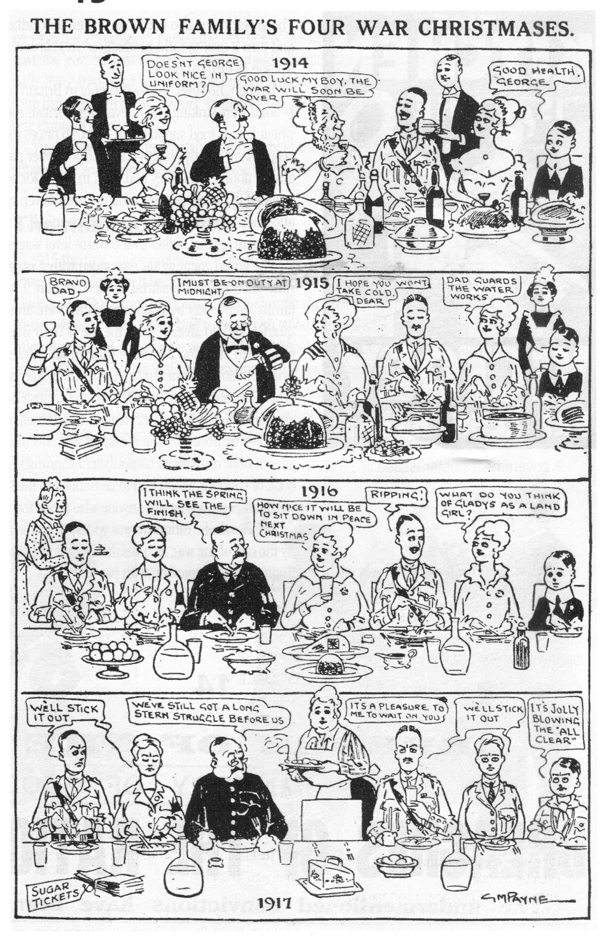

on duty = at work

Waterworks = water supply system

Ripping = fantastic

To stick out = to endure to the end

Stern = severe

Struggle = fight

It’s jolly blowing the “all clear”= it will be great when everything is over!

