Task:
- Using the document (page 2) and your knowledge, fill in the following tables to answer the question: “How was the British home front organized to face WWI?”

Introduction
Catchphrase
Key words or date to explain
Document’s presentation
Key question
Outline of the presentation (part 1, 2, 3?)

Development:
Title of the part | Information from the document | Personal knowledge
Part 1:
Part 2:
Part 3 (maybe)

Conclusion
Main ideas summary
opening (optional)

- Using your table, create a 5mn audio recording to answer the following question:“How was the British home front organized to face WWI?” and send it to me by WatsApp. Your audio must be about 5mn long, with a complete introduction, the explanation of the documents -drawing on your knowledge- and a conclusion.
G. M. Payne, “The Brown family’s four Christmases”, in the Sunday Pictorial, 23 September 1917:
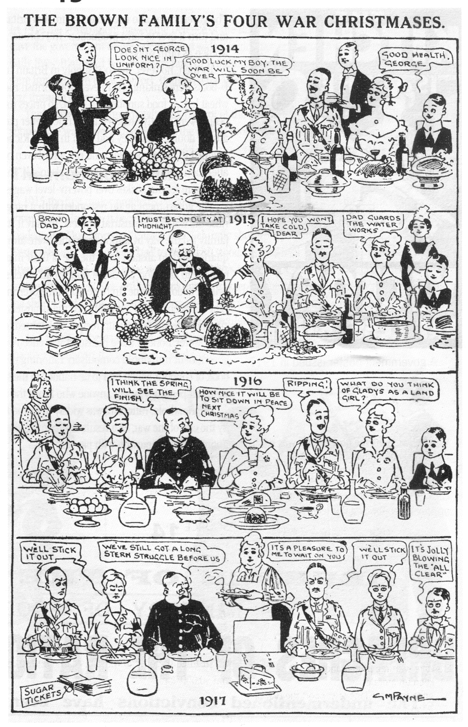

on duty = at work

Waterworks = water supply system

Ripping = fantastic

To stick out = to endure to the end

Stern = severe

Struggle = fight

It’s jolly blowing the “all clear”= it will be great when everything is over!

